

**JSPM’s**

**Bhivarabai Sawant Institute of Technology and Research, Wagholi, Pune-412207.**

**Department of Computer Engineering**

**WORKBOOK**

**BE COMPUTER SEM I**

**A.Y. 2020-2021**

**SUBJECT: ARTIFICIAL INTELLIGENCE AND ROBOTICS(AIR)**

**UNIT NO: 2**

**PROBLEM DECOMPOSITION AND PLANNING**

**Completed By:**

**Student Name: A. Shiva Surya Saran**

**Roll No: 20**

**Division: BE-B**

**Syllabus Covered**

|  |  |  |
| --- | --- | --- |
| **Unit II** | |  | | --- | |  |   **PROBLEM DECOMPOSITION AND PLANNING** |
| Problem Decomposition : Goal Trees, Rule Based Systems, Rule Based Expert Systems. Planning : STRIPS, Forward and Backward State Space Planning, Goal Stack Planning, Plan Space Planning, A Unified Framework For Planning. Constraint Satisfaction : N-Queens, Constraint Propagation, Scene Labeling, Higher order and Directional Consistencies, Backtracking and Look ahead Strategies. | |

1. **Define the following:**

**Expert Systems:**

An expert system is an AI software that uses knowledge stored in a knowledge base to solve problems that would usually require a human expert thus preserving a human expert’s knowledge in its knowledge base. They can advise users as well as provide explanations to them about how they reached a conclusion or advice.

**Constraint Satisfaction Problem:**

A constraint satisfaction problem (CSP) is a problem that requires its solution within some limitations or conditions also known as constraints. It consists of the following:

* A finite set of variables which stores the solution (V = {V1, V2, V3,....., Vn})
* A set of discrete values known as domain from which the solution is picked (D = {D1, D2, D3,.....,Dn})
* A finite set of constraints (C = {C1, C2, C3,......, Cn})

**Backward Chaining:**

Backward-chaining is also known as a backward deduction or backward reasoning method when using an inference engine. A backward chaining algorithm is a form of reasoning, which starts with the goal and works backward, chaining through rules to find known facts that support the goal.

**Goal Stack Planning:**

The reasoning strategy used by STRIPS is goal stack planning. In goal stack planning, the problem solver makes use of a goal stack GS that contains both subgoals and actions that have been proposed to satisfy those subgoals. It also relies on a database DB that describes the current situation, and a set of actions described by precondition, add and delete lists.

**N queen problem**

This problem is to find an arrangement of N queens on a chess board, such that no queen can attack any other queens on the board.

The chess queens can attack in any direction as horizontal, vertical, horizontal and diagonal way.

A binary matrix is used to display the positions of N Queens, where no queens can attack other queens.

**2) The following fig. shows architecture. Name it. Also explain various components of an expert systems.**

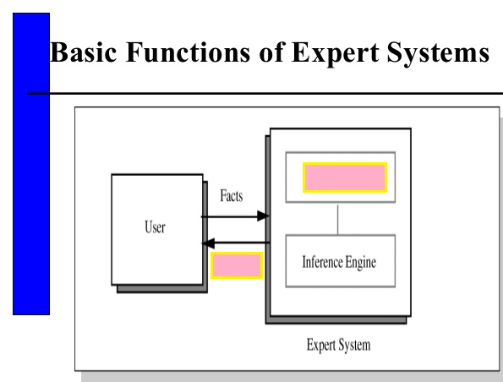

* **Knowledge base:** The knowledge base represents facts and rules. It consists of knowledge in a domain as well as rules to solve a problem, procedures and intrinsic data relevant to the domain.
* **Inference engine:** The function of the inference engine is to fetch the relevant knowledge from the knowledge base, interpret it and to find a solution relevant to the user’s problem. The inference engine acquires the rules from its knowledge base and applies them to the known facts to infer new facts. Inference engines can also include an explanation and debugging abilities.
* **Knowledge Base:** The function of this component is to allow the expert system to acquire more and more knowledge from various sources and store it in the knowledge base.
* **User interface:** This module makes it possible for a non-expert user to interact with the expert system and find a solution to the problem.
* **Explanation module:** This module helps the expert system to give the user an explanation about how the expert system reached a conclusion.

**3) Differentiate between the following:**

|  |  |  |
| --- | --- | --- |
| **Sr. No.** | **State Search Space Planning** | **Plan Space Planning** |
| 1. | state-space search: search through graph of nodes representing world states. | Plan-space search: search through  graph of partial plans through nodes, arcs and solutions. |
| 2. | A n action that can change the system from one state to another (e.g. a move in a game) is represented by a link from one node to another. | Each node of the search space is a partial plan. |

**4) State n-queen problem. One of the possible solution for 8 queen problem is given below. Draw any other two possible solutions/configurations of 8-queen/4-queen problem.**

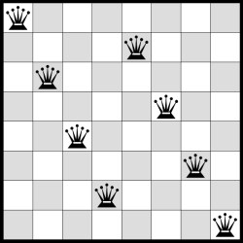

Fig. 8 queen problem solution

The N Queen is the problem of placing N chess queens on an N×N chessboard so that no two queens attack each other. For example, following is a solution for 4 Queen problem.

The expected output is a binary matrix which has 1s for the blocks where queens are placed.

Other Possible solutions are for 8 queen puzzle:

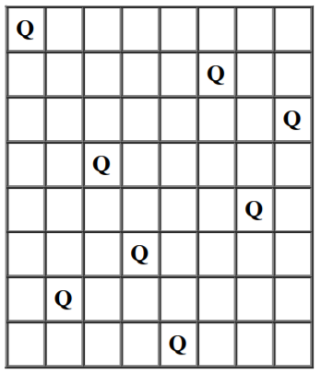

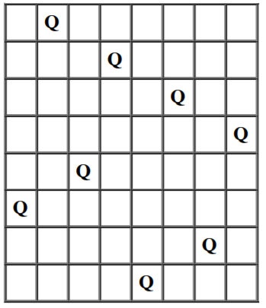

**---------------------------------------EVALUATION SHEET ------------------------------**

|  |  |  |  |
| --- | --- | --- | --- |
| **Ques.no** | **Max.Marks** | **Marks Obtained** | **Remark** |
| 1 | 5 |  |  |
| 2 | 5 |  |  |
| 3 | 4 |  |  |
| 4 | 6 |  |  |
| **TOTAL** | **20** |  |  |

**SUBJECT INCHARGE DAC HOD**